**Practical No 11**

**Description:**

Cross Browser Testing is a type of functional test to check that your web application works as expected in different browsers.

**Aim: To perform the Selenium cross browser compatibility test.**

**Theory:**

Cross browser testing refers to testing a website in multiple browsers like IE, Chrome, Firefox to check its efficacy on each. Cross-browser compatibility is the ability of the website or web application to function across different browsers and operating systems. However, manually testing a website across multiple browsers is exceptionally tedious. Consider a situation in which 100 test cases have to be run manually. Now imagine that the same tests have to be run on five different browsers. The time taken becomes exponentially longer. However, if these tests are automated using Selenium, then they can be run simultaneously and in far less time. It will also prevent any issue arising from human error.

**Why is Cross Browser Testing important?**

Browser vendors follow Open Web Standards, but they have their own interpretations of it. Since they each render HTML, CSS, and JavaScript in unique ways, thoroughly debugging a website’s source code is not enough to ensure that the site will look and behave as intended on different browsers (or different versions of a single browser). So, it falls to web developers to abstract browser differences. Cross browser compatibility testing helps with that by pinpointing browser-specific compatibility errors so they can be debugged quickly. It helps ensure that a site is not alienating a significant part of its target audience–simply because the website does not work on their browser-OS.

**Reason Cross Browser Issues**

* Font size mismatch in different browsers.
* JavaScript implementation can be different.
* CSS,HTML validation difference can be there.
* Some browser still not supporting HTML5.
* Page alignment and div size.
* Image orientation.
* Browser incompatibility with OS. Etc.

**Cross browser Testing**

First, we need to download nodejs, so download it from <https://nodejs.org/en/download> with any browser.

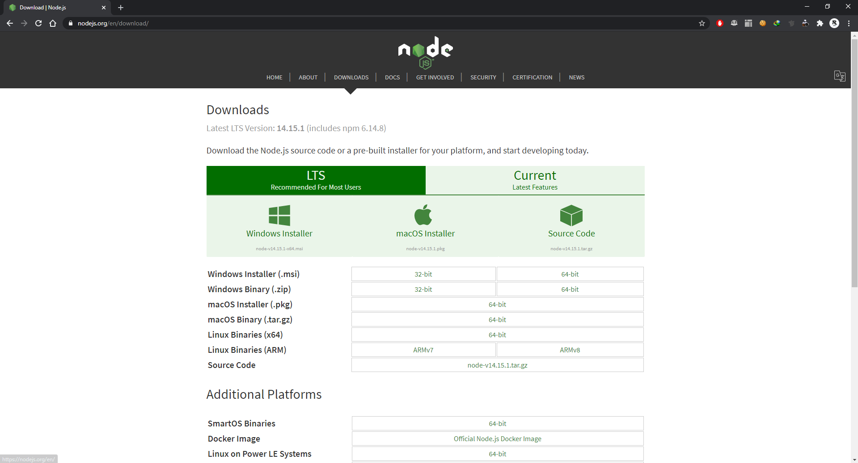

Install the latest version of nodejs and open node.js in command prompt.

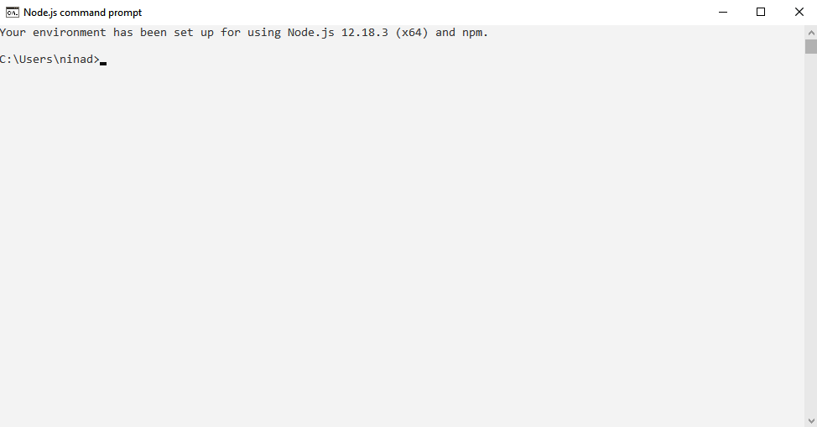

Run the following command in the terminal to install the dependencies packages.

> node -v

> npm -v

> npm install -g selenium-side-runner

> npm install -g chromedriver

> npm install -g geckodriver

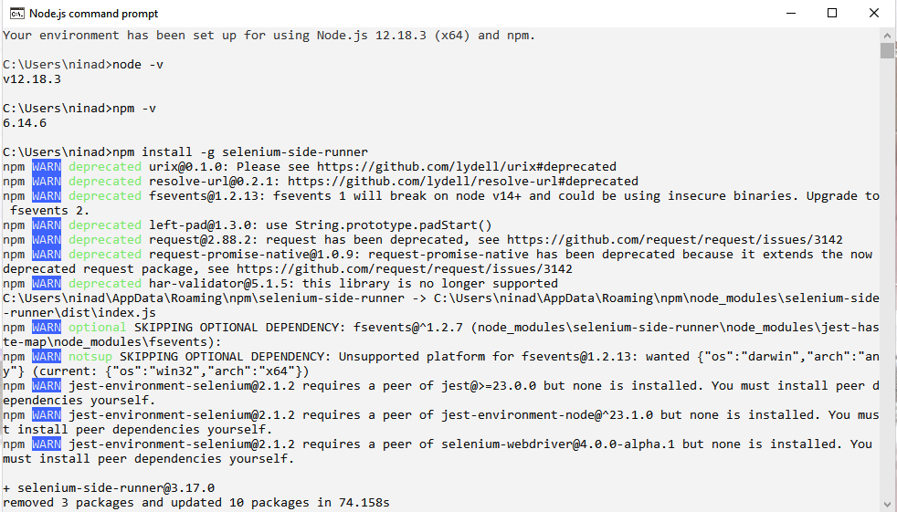

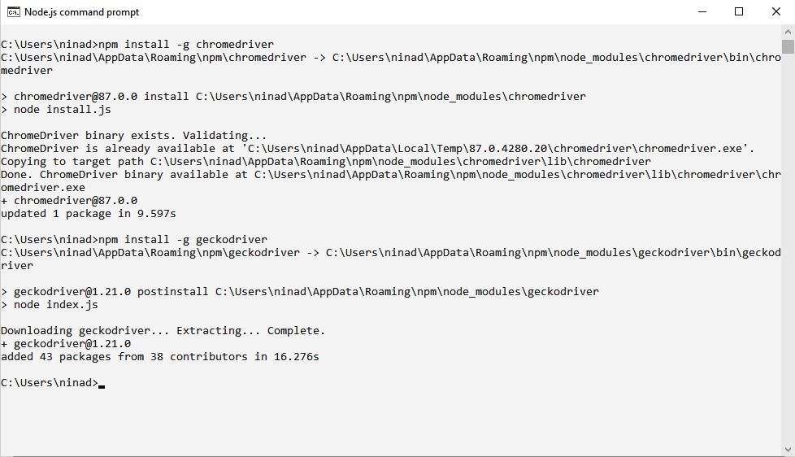

After running all the commands download chrome driver for selenium. (select the version by checking the version in node.js cmd)

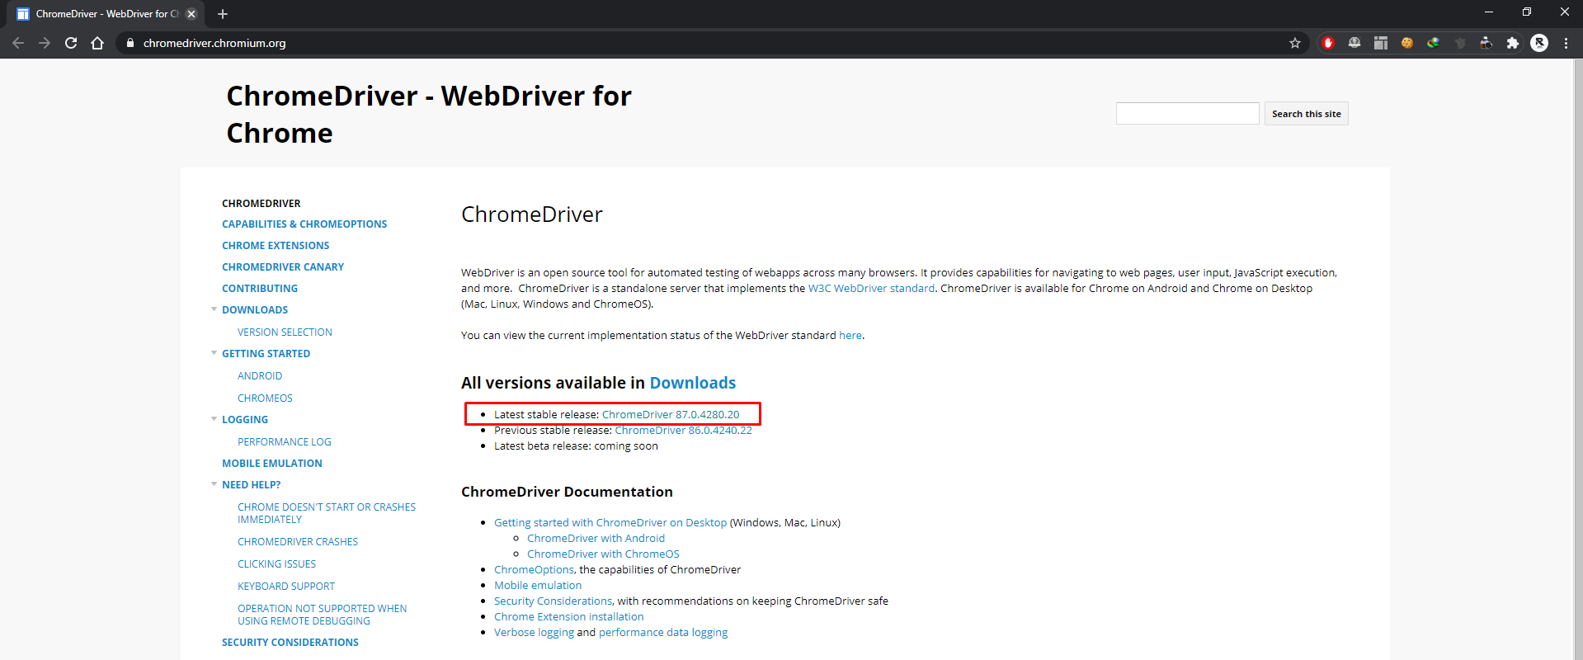

Extract the .exe file in a specific folder.

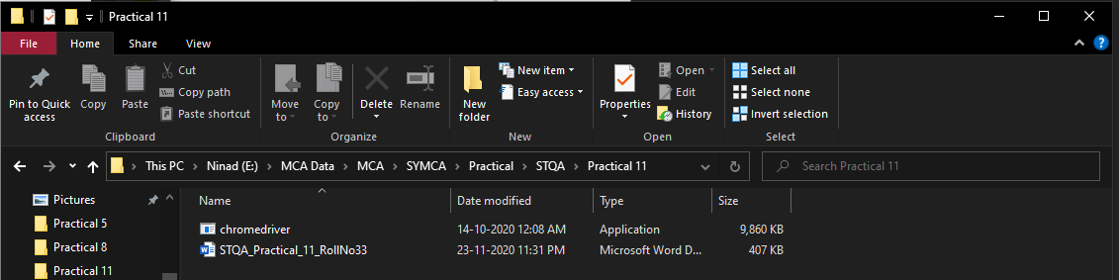

Create a test suite consisting of at least 1 test and save it in the same folder of chrome driver

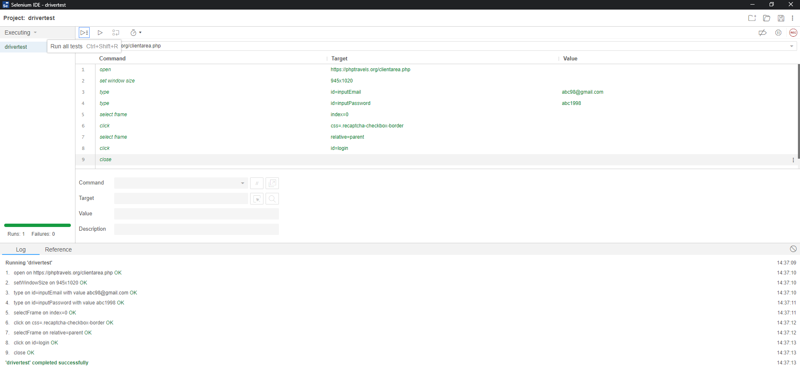

Now we need to set the path of that folder in environment variables for example E:\MCA Data\MCA\SYMCA\Practical\STQA\Practical 11

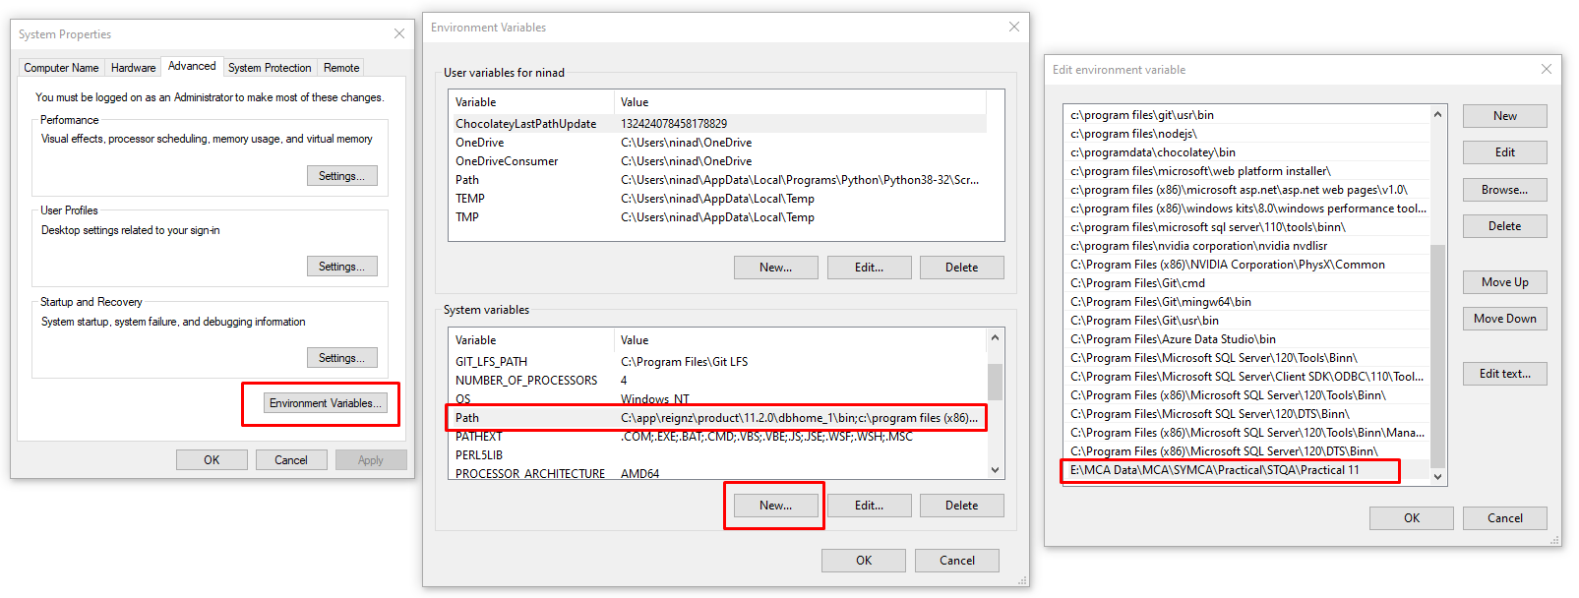

Now go to the path in which the file is stored and then execute it.

> selenium-side-runner your-project.side

For e.g. : selenium-side-runner drivertest.side

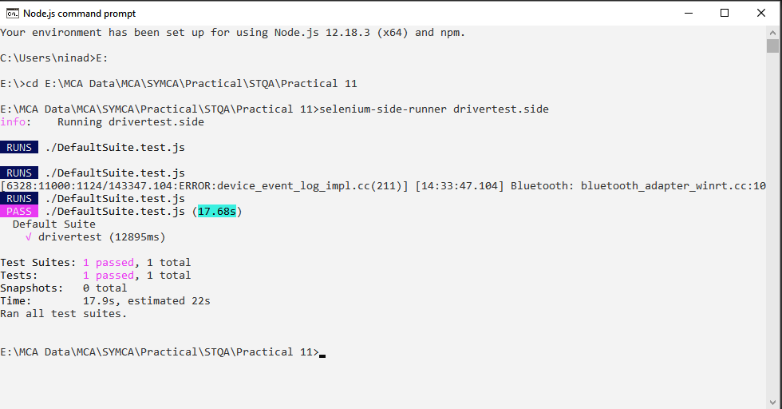

**Conclusion: We have performed the Selenium cross browser compatibility test.**